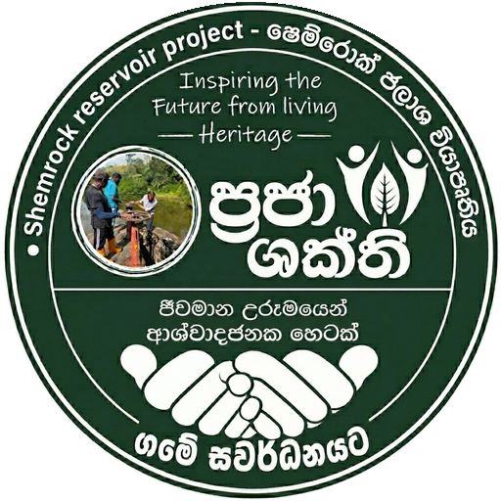 | PRAJA SHAKTHI  Shemrock Reservoir Project — Living Heritage  Inspiring the future from the living heritage

MONTHLY PROJECT UPDATE
Reporting Month: ______________ | Year: __________
Report Details
Prepared by | Name / role
Electoral Divisions | Nawalapitiya electoral divisions
Date prepared | DD / MM / YYYY
1. Eco Products — Progress
- Products made / promoted this month (natural leaves, recycled materials): …
- Production quantity and sales / orders: …
- New products or improvements introduced: …
2. Environment-Friendly Activities
- Use of recycled materials and natural leaves: …
- Waste reduction, recycling and awareness activity: …
3. Praja Shakthi Development Activities — Nawalapitiya
- Community enterprise support (women's groups, seniors): …
- Markets, fairs and promotion events held: …
- Reservoir, tree-planting and watershed activities: …
4. Highlights & Achievements
- Key achievement of the month: …
- Community participation / beneficiaries reached: …
5. Plans for Next Month
- Planned activities and targets: …
6. Photos & Attachments
List selected event photos attached / to be uploaded to the website gallery:
- Photo 1 — caption / event: …
- Photo 2 — caption / event: …
- Photo 3 — caption / event: …

Praja Shakthi — Shemrock Reservoir Project | ජීවමාන උරුමයෙන් ආශ්වාදජනක හෙටක්
Reusable monthly template — fill in the details each month, save with the month's name, and publish on the Eco Products page.

